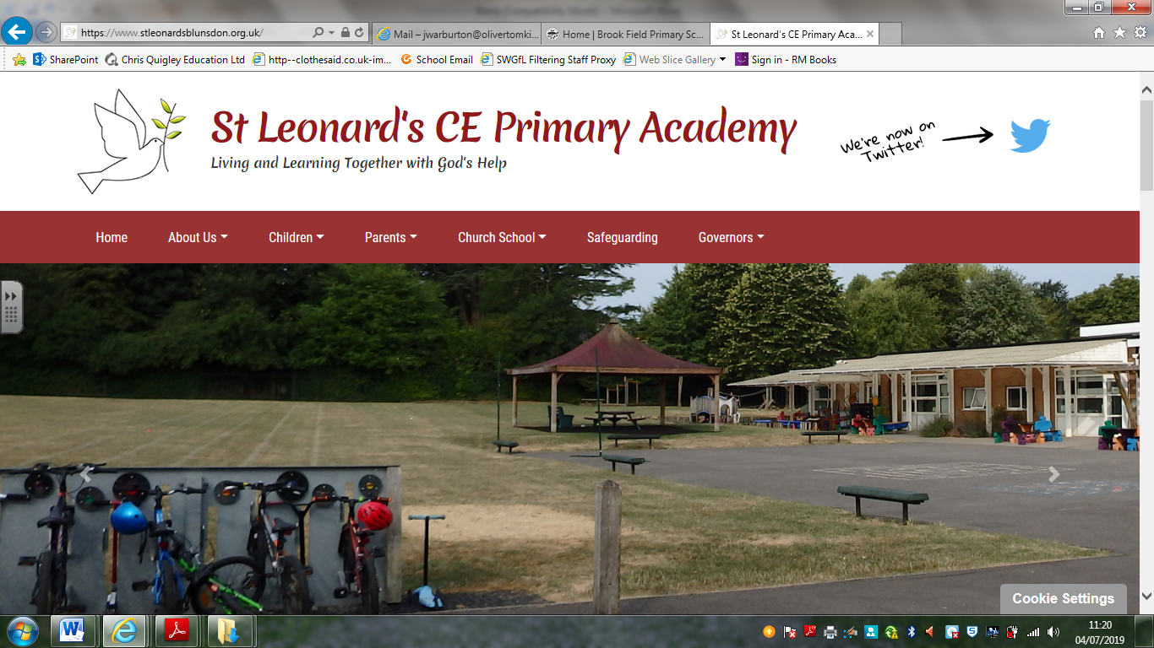

**PSHE Policy 2024-25**

This policy should be read in line with our schools’ vision statement, ‘Living and Learning Together with God’s Help’, as it encompasses everything that we do. It stems from the Christian belief that all children are to believe in themselves, being a unique human being, made by God and Loved by him, and so develop a love of lifelong learning and a sense of community, as we grow together as part of God’s family; being with God and having his help as we live and learn together in all that we are and seek to be

**Intent: What do we want children to learn?**

It is our intention that when children leave St Leonard’s, they will do so with the knowledge, understanding and emotions to be able to play an active, positive and successful role in today’s diverse society. We want our children to have high aspirations, a belief in themselves and realise that anything is possible if they put their mind to it. In an ever-changing world, it is important that they are aware, to an appropriate level, of different factors which will affect their world and that they learn how to deal with these so that they have good mental health and well-being.

Our PSHE curriculum develops learning and results in the acquisition of knowledge and skills which will enable children to access the wider curriculum and prepare them to be a global citizen now and in their future roles within a global community. It promotes the spiritual, moral, cultural, mental and physical development of pupils, preparing them for the opportunities, responsibilities and experiences for later life. Our Relationships, Sex and Health Education enables our children to learn how to be safe and to understand and develop healthy relationships, both now and in their future lives.

**Implementation: How** **do we do this at St Leonard’s CE Primary Academy?**

EYFS – In the Foundation Stage, PSHE and citizenship is taught as an integral part of topic work and is embedded throughout the curriculum. The objectives taught are the Personal, Social and Emotional Development statements from ‘Development Matters in the EYFS’ and the PSED Early Learning Goals. Reception also uses the Jigsaw Scheme of Work materials.

Key Stage 1 and Key Stage 2 – At Key Stage 1 and 2, PSHE is taught through a clear and comprehensive scheme of work in line with the National Curriculum.   
Children are taught PSHE using ‘Jigsaw’ which is a spiral, progressive scheme of work and ‘aims to prepare children for life, helping them to know and value who they are and understand how they relate to other people in this ever-changing world’. There is a strong emphasis on emotional literacy, building resilience and nurturing mental and physical health. It includes mindfulness to allow children to advance their emotional awareness, concentration and focus.

In addition to Relationships Education, we also teach aspects of Sex Education that is covered in our Science Curriculum. Alongside this, we teach about different kinds of relationships, including LGBT relationships and gender identity because it is important that our children should have an understanding of the full diversity of the world they live in and be prepared for life in modern Britain. Sex Education aspects of PSHE are also taught through the ‘Jigsaw’ scheme of work.

PSHE is taught through Jigsaw’s six half termly themes with each year group studying the same unit at the same time (at their own level):

Autumn 1: Being Me in My World  
Autumn 2: Differences (including anti-bullying)  
Spring 1: Dreams and Goals  
Spring 2: Healthy Me  
Summer 1: Relationships  
Summer 2: Changing Me (including Sex Education)

It also identifies links to British Values and SMSC and is taught in such a way as to reflect the overall aims, values and ethos of the school.

Wider Curriculum

* We believe that focusing on developing a ‘Growth Mindset’ in our children will help them to build resilience, independence and confidence; embrace challenge; foster a love of learning; and increase their level of happiness. We do this through the language we use in class, praising children for their efforts and using language to encourage children to change their way of thinking. This supports both our school and PSHE aims and values, and we focus on Growth Mindset in all aspects of school life.
* PSHE, including SMSC and British Values, is an integral part of the whole school curriculum and is therefore, often taught within other subject areas.
* Visitors such as emergency services and the school nurse complement our PSHE curriculum to offer additional learning.
* We encourage our pupils to develop their sense of self-worth by playing a positive role in contributing to school life and the wider community. We challenge all of our pupils to look for opportunities to show the school values; Thankfulness, Respect, Compassion, Courage, Forgiveness, Perseverance, Friendship, Trust, Generosity, Justice, Service and Truthfulness.
* Assemblies are linked to PSHE, British Values and SMSC and cover any additional sessions that would benefit the whole school.
* PSHE, BV and SMSC displays throughout the school, reinforce the PSHE curriculum, enabling children to make links.

PSHE and RSE is compulsory for all children. Should parents wish for their child not to take part in RSE lessons, they will need to arrange a meeting with the headteacher to discuss this.

**Impact: What will children be able to do once they have left St Leonard’s CE Primary Academy?**

By the time our children leave our school they will:

* be able to approach a range of real-life situations and apply their skills and attributes to help navigate themselves through modern life
* be on their way to becoming healthy, open minded, respectful, socially and morally responsible, active members of society
* appreciate difference and diversity
* recognise and apply the British Values of Democracy, Tolerance, Mutual respect, Rule of Law and Liberty
* be able to understand and manage their emotions
* be able to look after their mental health and well-being
* be able to develop positive, healthy relationship with their peers both now and in the future
* understand the physical aspects involved in Relationships, Sex and Health Education as an age appropriate level
* have respect for themselves and others
* have a positive self-esteem

**Inclusion**

Throughout, it is our aim to provide equal opportunity and access to the PSHE curriculum for all of our pupils regardless of disability, race or gender. We will ensure that the rich and rewarding PSHE lessons and discussions are open to all our pupils. We recognise our duty to all pupils to provide them with a PSHE curriculum that meets the special needs of individual pupils. We aim at all times through our planning, to respond to the diverse range of pupils learning needs. We understand that our pupils bring to school different experiences, interests and strengths, which influence the way they learn. We aim to provide for all children to achieve, planning with an awareness of these needs and having high expectations at their best level. We will make every effort to ensure that the methods and materials used are free from prejudice or bias against any particular group and be aware that we need to target and adjust to meet the needs of some. EAL pupils will be supported in their understanding of the themes and ideas explored in PSHE and we feel it is important to recognise the importance of their first language, make links with the home and to make use of home language to assist learning. It is important to ensure that in these circumstances the child’s cognitive ability is taken into account when assessing their work.

**Assessment, Recording and Reporting.**

Assessment for learning is embedded into classroom practice. The results from this assessment are used to inform future planning. At the end of every term, teachers will update the progression of skills document to record children’s attainment. Teaching is evaluated and modified where necessary. Each teacher identifies the next steps for the children in their class.

Parents are invited to parent interviews with the class teacher twice a year. They receive an annual written report that will include their child’s progress.

**Staff Development**

Teachers are expected to keep up to date with subject knowledge and use current materials that are available in school or online. Training needs are identified as a result of whole school monitoring and evaluation, performance management and through induction programs. These will be reflected in the School Development Plan. The PSHE lead will arrange for relevant advice and information, such as feedback from courses or newsletters, to be disseminated. Where necessary, the PSHE lead and head teacher will organise or lead school-based training.

**Monitoring and Evaluation**

At St Leonard’s, we continually review and monitor practice to ensure thorough coverage and good teaching standards are maintained to meet the needs of all our children. The monitoring and evaluation of teaching and learning, in PSHE, is carried out by the PSHE Lead and the Head teacher.

This takes place in the following ways:

* Annual audit and review of subject by the subject lead, to inform the School Development Plan.
* Analysis of progress
* Leading staff meetings focusing on PSHE areas where new national or local practice and initiatives will improve current practice and also on areas highlighted in School Development Plan and Annual Audit and Review.
* Discussion at staff meetings to ensure consistency of approach, standards and expectations.
* Scrutiny of work, sampling of records etc. from monitored children.
* Collection of work samples to demonstrate achievement, range of activities, special events.
* Observation of PSHE lessons
* ‘Learning Walks’ to focus on a particular aspect of PSHE.
* Feedback to staff on areas of strengths and areas of development.

It is the task of the PSHE Lead to manage the subject across the year groups throughout the whole school.

This involves:

* Being responsible for policies, schemes and all documentation relating to PSHE (with support from the SMT) and ensuring they relate to current practice and are familiar to all staff.
* Encouraging and supporting all staff in the teaching of PSHE.
* Promoting good practice, keep abreast of new development, working through current issues in a balanced informed way, being committed to school improvement.
* Monitoring PSHE throughout the school in a range of ways, to ensure consistent practice and children make progress.
* To budget for and manage resources.
* The PSHE Lead is responsible for purchasing or organising all resources for this subject; the purchase, organisation, allocation storage and management of all resources for the PSHE Curriculum.

This policy was created by the PSHE lead, in consultation with the Headteacher and teaching team, and its implementation is seen as the responsibility of all staff. Its use and effectiveness will be supported and monitored by the PSHE Lead, on behalf of the Head Teacher and Governors.

|  |  |
| --- | --- |
| Written by: | Hayley Welch |
| Owner: | Headteacher |
| Status: | Pending ratification |
| Approval date: | September 2024 |
| Review date: | September 2026 |