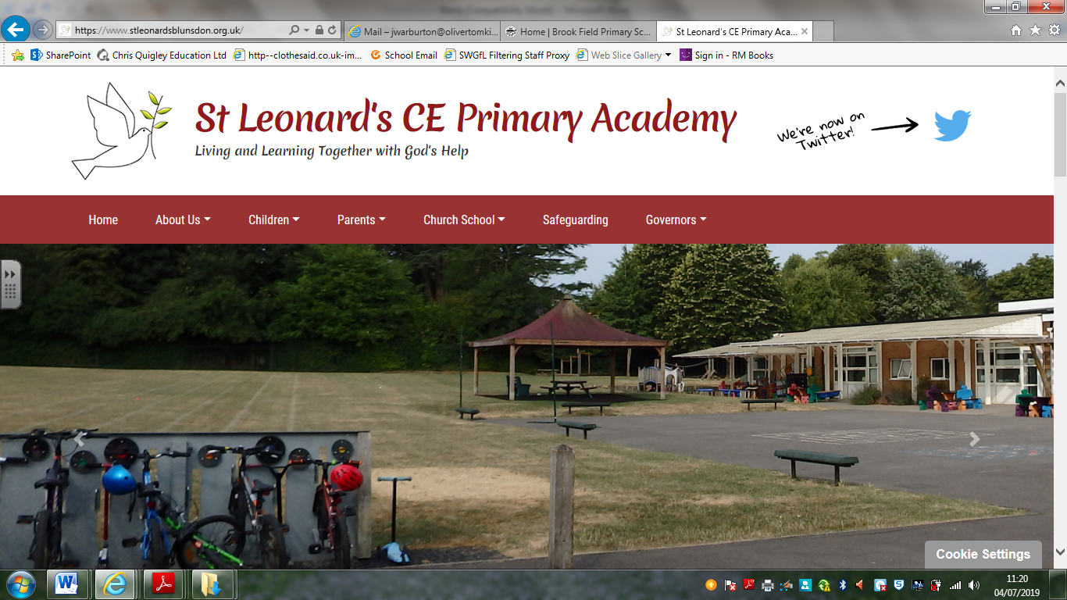

**Remote Learning Plan**

**September 2024 – September 2026**

This plan offers remote learning opportunities for all pupils where the school has had to close due to Coronavirus or for a short period of time due to bad weather or other similar circumstances.

For longer term closures, where households have limited ICT access help will be offered by school to support children with their learning via the loan of accessing hard-copies of work and resources. This plan will be applied in the following instances:

1. An individual is self-isolating awaiting the results of a test/has or has a positive test within the household;

2. A group of children are self-isolating because of a case of coronavirus in the bubble;

3. A whole bubble or cohort is self-isolating because of an outbreak of coronavirus

4. The school is in a government lockdown

The plan complies with the expectations and principles outlined in the DFE document Guidance for Full Opening of Schools.

**Software and online platforms**

In the event of a school closure due to Coronavirus, children will remain in contact with their class teacher through Teams (learning platform) class sessions, telephone calls where appropriate and emails. My Maths, TT Rockstars, and Classroom Secrets will all be utilised to support learning.

Daily Teams calls will be set up at specific times throughout the day; parents and carers will be informed about the times in advance through parent mail. Daily tasks and instructions will be posted onto Teams and accompanying resources/links will be attached to each lesson when appropriate on My Maths or Classroom Secrets.

In Reception, Year 1 and Year 2, instructions and work will be posted on Tapestry.

Teachers will set work in-line with our current curriculum, supplemented by a range of Internet resources including BBC bitesize and Oak Academy.

In the event of a short school closure due to bad weather or other similar circumstances, parents will be informed on parent mail of a time when work will be set and work will be available on My Maths and Classroom Secrets for children to access.

In Reception, Year 1 and Year 2, instructions and work will be posted on Tapestry.

In the event of any form of isolation and loss of learning caused by Coronavirus, parents must understand that engagement in home learning is compulsory, as is the expectation that St Leonard’s CE Primary Academy makes provision available and accessible to all. However, if children themselves are too ill to attend then they should not be expected to engage in home learning.

It is acknowledged that this will be a challenging time and access to devices may be limited if a whole household is isolating. St Leonard’s CE Primary Academy will endeavour to work closely with all families to ensure their individual needs are met.

**Policy written: September 2024**

**Policy written by: Head teacher**

**Policy Ratified: October 2024**

**Review of Policy: September 2026**